**IDy work flow process document**

Description and business model

We would be going step by step in order to understand the whole work flow of IDy. Since we are making B2C product we might have to follow this work flow.

What would happen when a user lands on [www.theidy.com](http://www.theidy.com)?

1. The user would see the home page and the contents of IDy website.
2. He or She can see the IDy of rest of the users.
3. He or She can able to register himself or herself on IDy website.

How the user would register on IDy ?

1. The user has to provide below basic information in order to create an account with IDy.
2. Name
3. Email Address
4. Mobile Number
5. Password

**Note**: We have to keep as simple as possible while registering the user, by getting very minimal information from the user. This is because some users get annoy while registering themselves if they find the form is too huge.

**Note:** Existing users cannot register themselves again.

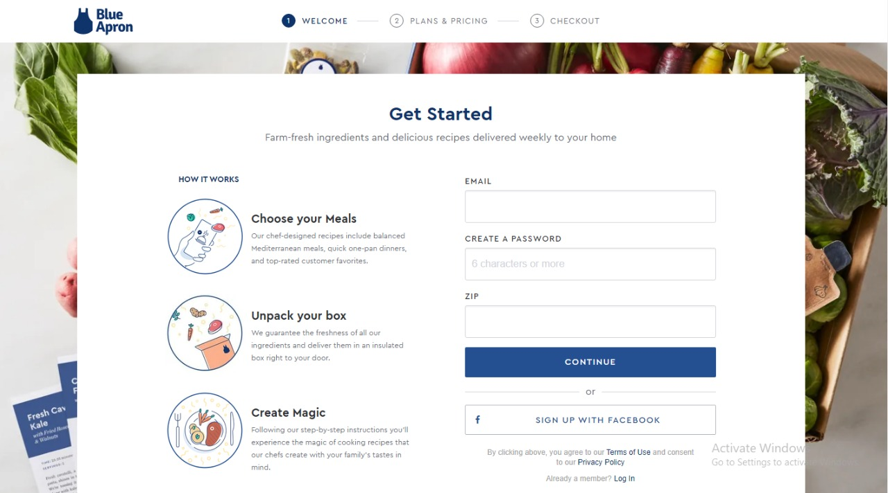

1. Once the user is successfully registered, IDy admin would send the automatic system generated email to the user confirming regarding his or her registration of an account with IDy.
2. Once the user is registered successfully, he or she would land on the subscription model, this is where the user would choose the plan.

How the user would subscribe to a plan?

1. Once the user made up his mind for a particular plan, he or she would click on the subscribe button and following would happen depending upon the below use cases.
2. If user is not registered then…

* We will prompt the user for the registration process.
* Once he is registered, we would navigate the user to the payment screen.
* Once the payment is successful, the user would land on the success page from where he or she can access the customer dashboard. The user would also get a success email over the subscription of the plan and in email he or she would get a link of customer dashboard e.g <https://www.theidy.com/customer/dashbaord> and a link to his or her IDy e.g https://www.theidy.com/dharmit.vyas

**Note:** If you check Facebook, they add the dot between first name and the last name of the user, for example https://www.facebook.com/dharmit.vyas

1. If the user is already registered then…

* We would be showing them a login or a sign-in model. This is because we would be needing the information regarding the user’s email address.
* The login can be done using Facebook, Google, OTP or with user’s credentials while he or she registered i.e emailID and Password.
* Once the login is successful, we would be navigating the user on the payment screen.
* Once the payment is successful, the user would land on the success page from where he or she can access the customer dashboard. The user would also get a success email over the subscription of the plan and in email he or she would get a link of customer dashboard e.g <https://www.theidy.com/customer/dashbaord> and a link to his or her IDy e.g <https://www.theidy.com/dharmit.vyas>

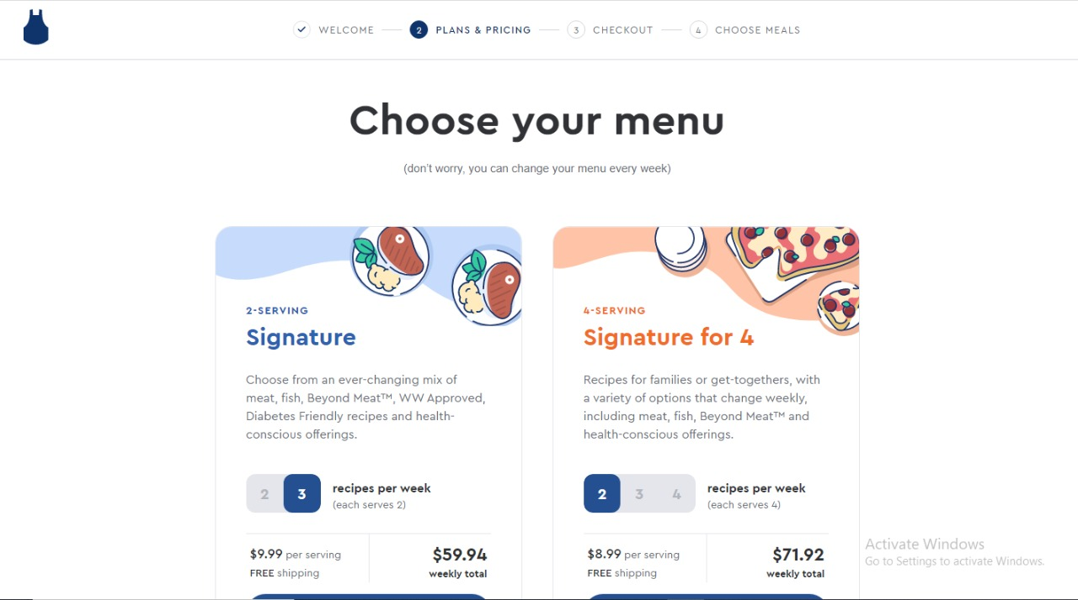

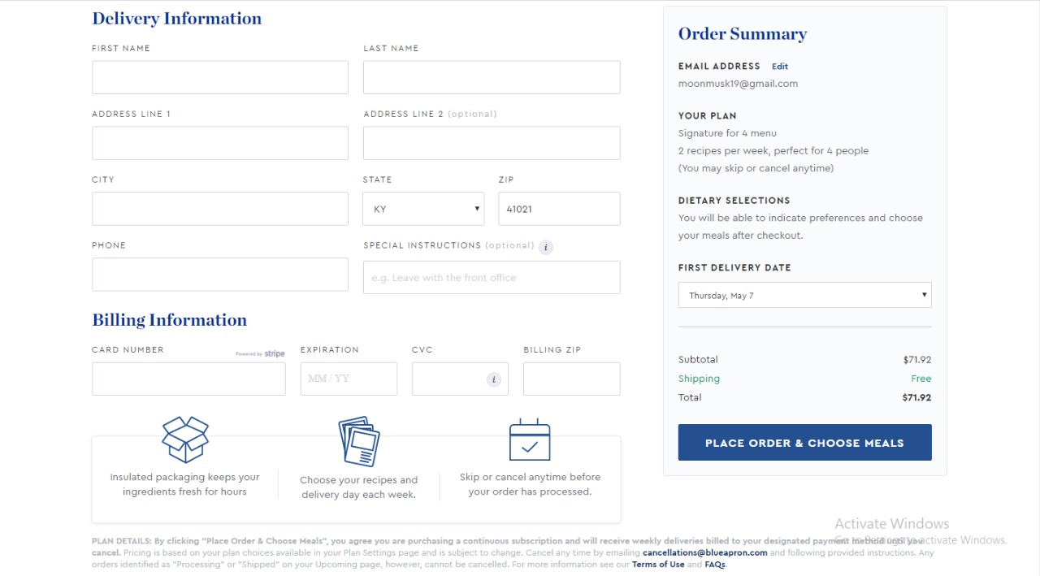

How the user would set his or her IDy for the first time?

1. The user can login or sign-in with Facebook, Google, OTP or IDy credentials from theidy website.
2. After the successful login the user would land on his dashboard. Which would look something like below.

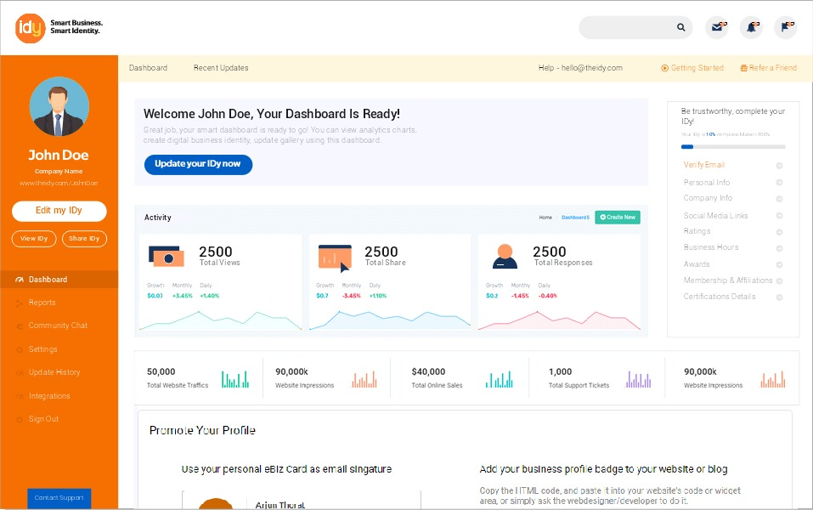

1. In the above diagram, when the user click on “Edit My IDy” option on the left hand side of the dashboard, the user would able to navigate to the new screen where he or she can update the information. The second screen might look like below.

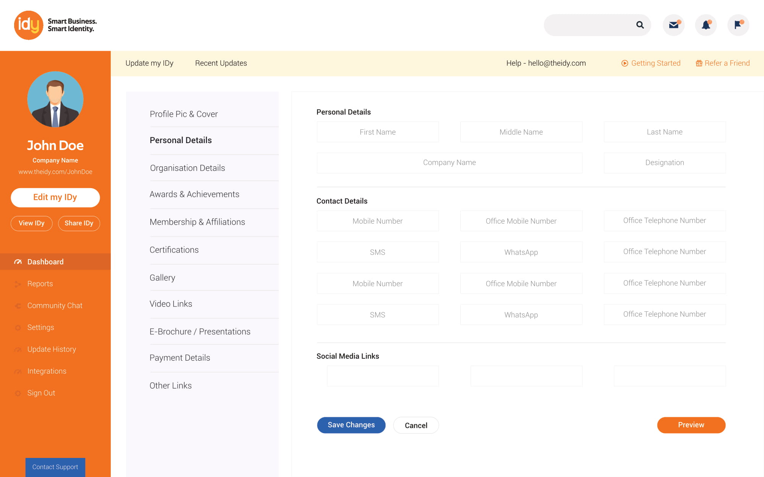

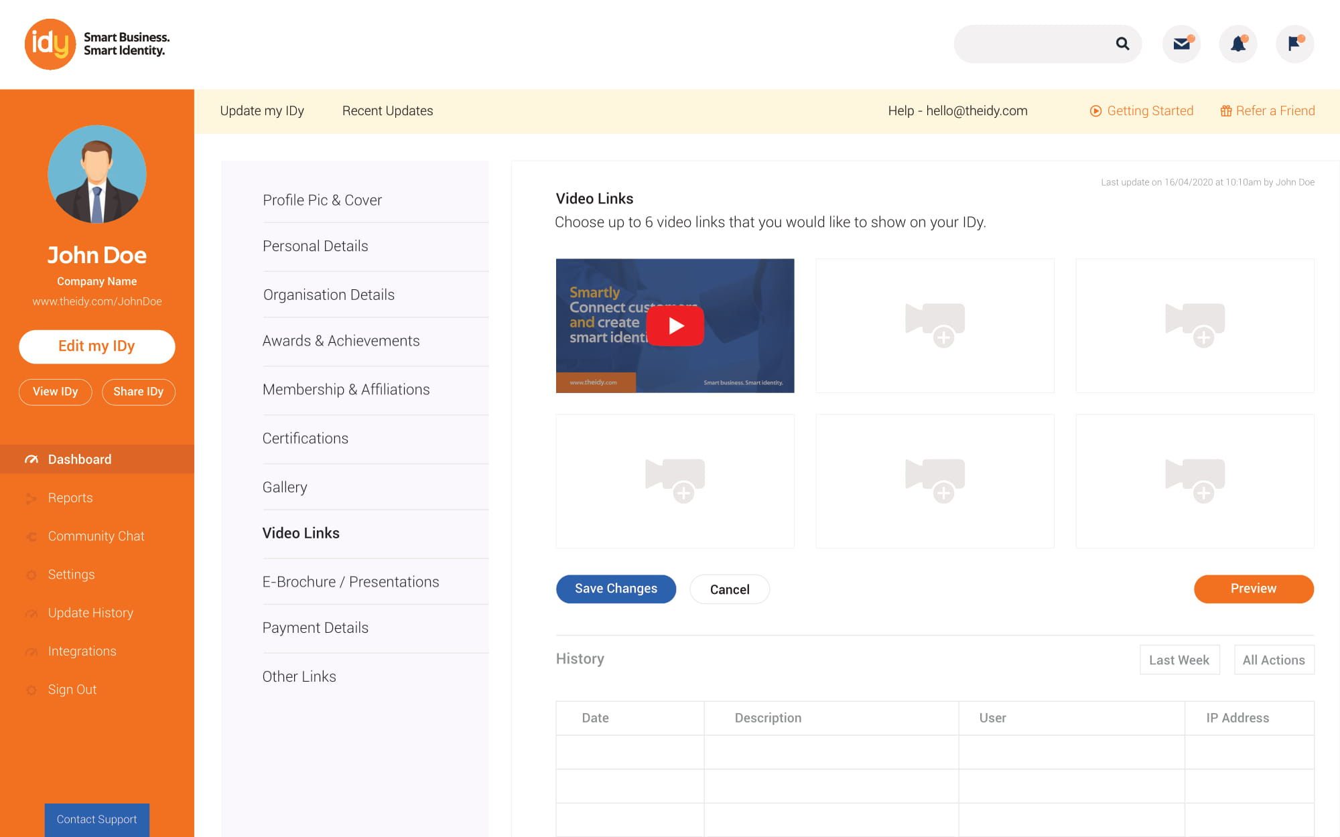

1. In the above screenshot, the left side panel of the dashboard would have links to all section where the user can edit and the right side section would have the UI controls from where the user would input the information.

Subscription expiration process:

1. Before 7 days of expiration of IDy, the user would receive an email stating that your IDy would be expire in next 7 days.
2. Before 2 days of expiration of IDy, the user would again receive an email stating about the expiration.
3. After the expiration of the IDy, the user would no longer be able to access the customer dashboard and his or her IDy link. For example, if my subscription is over and I try to access <http://theidy.com/dharmit.vyas> then I would be redirected to 404 page , IDy not found.
4. After the expiration the user would can again renew its IDy by subscribing to the available plans.

Enterprise Module Flow:

***Note: Registration, Subscription and Payment procedure would remain same as the normal user. Only thing is during registration the subscriber has to put in number of employees for whom the IDy needs to be created.***

1. When a super admin of that enterprise or a company lands on the dashboard the user would able to see the option to view or create the company’s employee’s IDy.
2. When a super admin of the company clicks on the view employee’s IDy the new screen would be shown up with the list of the employees. Each employee IDy can be viewed and can be edited.
3. On the view employee screen, we might also give an option to create the employees IDy.
4. When the super admin click on the create employees IDy then a new screen would be shown up to create the IDy.
5. The super admin can set the user friendly name of employees IDy.
6. The super admin would have the full control on the update activities of employees IDy.
7. The super admin can also delete the employees IDy.
8. The super admin can set the permission whether their employees can edit the IDy or not. The permission can be set at IDy section level. For example, the super admin can set the permission to “Yes” if the the employee can edit the about us section or can change the profile pic.